**INTI International College Penang School of Engineering and Technology**

**3+0 Bachelor of Science (Hons) in Computer Science, in collaboration with Coventry University, UK**

**3+0 Bachelor of Science (Hons) in Computing, in collaboration with Coventry University, UK**

**Coursework cover sheet**

**Section A - To be completed by the student**

|  |  |
| --- | --- |
| Full Name: SULAIMAN SIDEK BIN AZMAN SHAH | |
| CU Student ID Number: P21013694 | |
| Semester: 3 | |
| Session:  **April 2022** | |
| Lecturer:  **Nadhrah Abdul Hadi (nadhrah.abdulhadi@newinti.edu.my)** | |
| Module Code and Title:  **4067CEM Software Design** | |
| Assignment No. / Title:  **Continuous Assessment** | % of Module Mark:  **50** |
| Hand out Date:  **22nd April 2022** | Due Date:  **Task 1: 13 May 2022, by 11.59pm**  **Task 2: 1 July 2022, by 11.59pm**  **Task 3: 17 June 2022, by 11.59pm.**  **Task 4: 17 June 2022, by 11.59pm.**  **Task 5: 17 June 2022, by 11.59pm.** |
| Penalties: No late work will be accepted. If you are unable to submit coursework on time due to extenuating circumstances, you may be eligible for an extension. Please consult the lecturer. | |
| Declaration: I/we the undersigned confirm that I/we have read and agree to abide by the University regulations on plagiarism and cheating and Faculty coursework policies and procedures. I/we confirm that this piece of work is my/our own. I/we consent to appropriate storage of our work for plagiarism checking.  Signature(s): ________________ ________ | |

**Section B - To be completed by the module leader**

|  |  |  |
| --- | --- | --- |
| Intended learning outcomes assessed by this work:  1. Understand and apply appropriate concepts, tools and techniques to each stage of the software development  2. Understand and apply design patterns to software components in developing new software  3. Demonstrate an understanding of project planning and working to agreed deadlines, along with professional, interpersonal skills and effective communication required for software production  5. Demonstrate an awareness of, and ability to apply, social, professional, legal and ethical standards as documented in relevant laws and professional codes of conduct such as that of the Malaysian National Computer Confederation. | | |
| Marking scheme | Max | Mark |
| 1. User Story Mapping 2. Setting up a GitHub Repository 3. Creating a Class diagram and design pattern selection 4. Creating a Prototype User Interface and Usability Testing 5. Discuss the ethical issue related to the software | 20  10  30  20  20 |  |
| Total | 100 |  |

**The 4067CEM assessment should be completed as a full individual work over the course of the module. The assessment output are only judged at the end of the module and not by the expectations during that week. The assessment should be undertaken individually. All submissions will be checked against each other and the internet for possible plagiarism.**

Activities – These activities consists of **50%** of your coursework marks. It will be run throughout the semester and there will be a final submission at the end of the semester. These activities consists of activities that will be done in a software design phase.

# System

College Events System for Students.

**Task 1**

**Vision**

**What’s the problems that currently are facing?**

The user which also known as student did not notice that there are many events that are taking place during their semester.

**How can we overcome this problem?**

By creating a website that are more attractive and easier so that it would not make too complicated for the users.

**Who is going to use this website?**

The users that are going to use this are student. The reason why is because they are more likely to be involve in many organizations and schools’ activity.

**Google Forms (Question)**

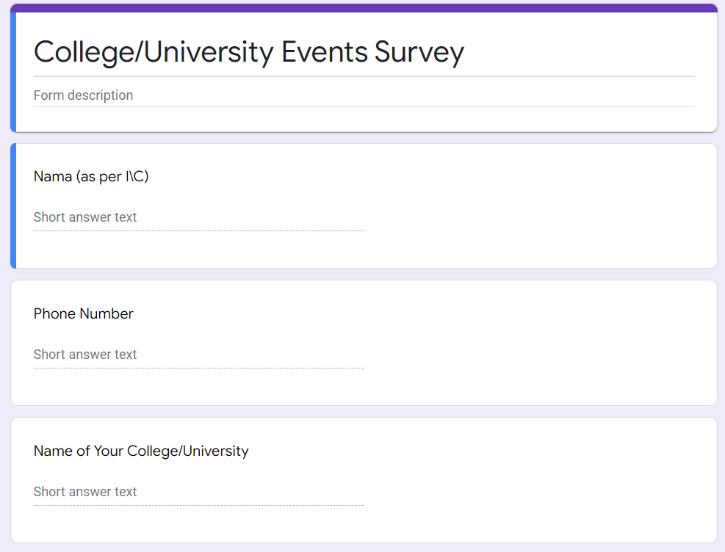

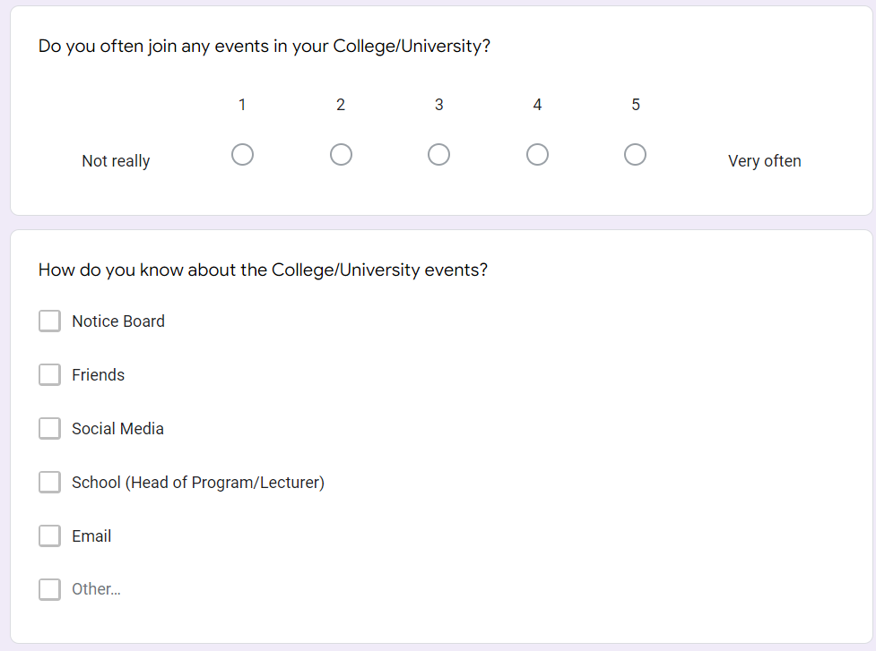

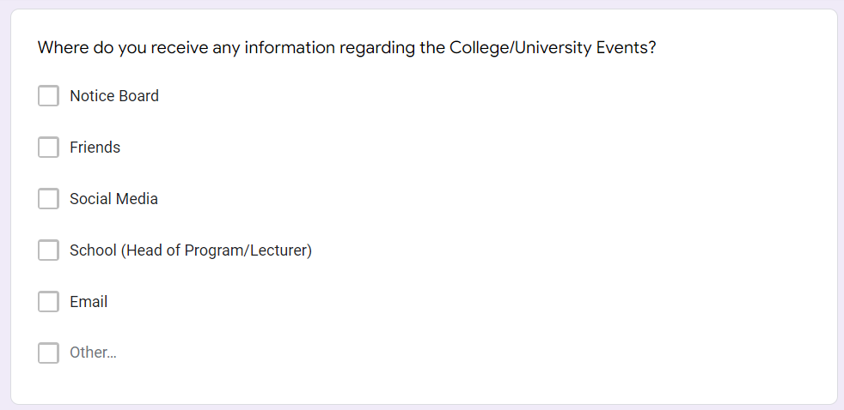

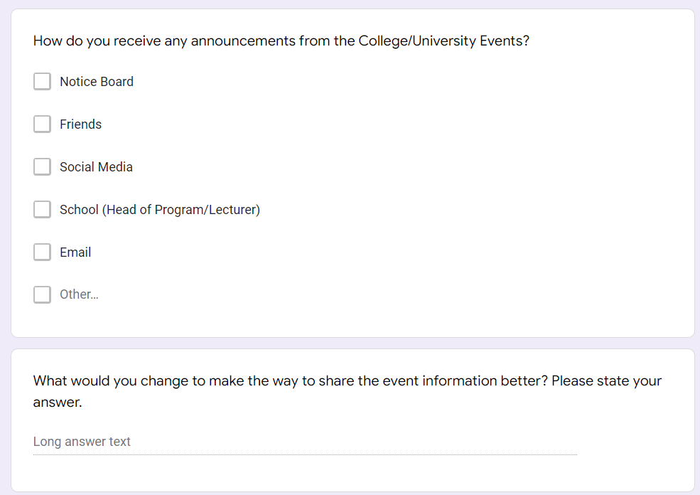

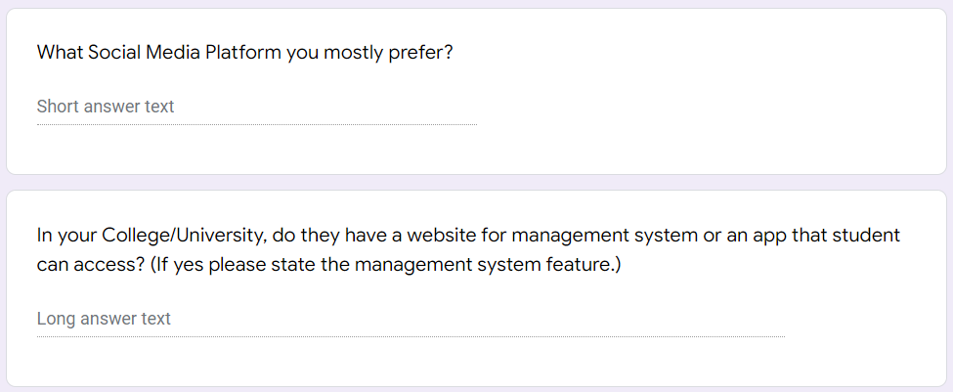

**Google Forms (Responses)**

**Q1**

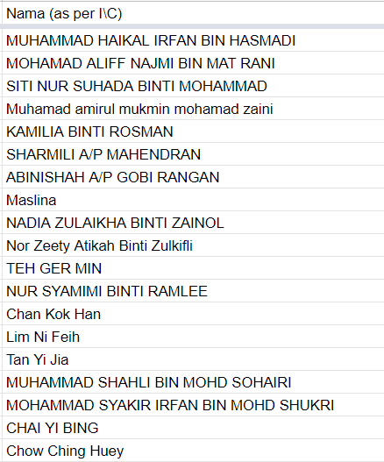

**Q2**

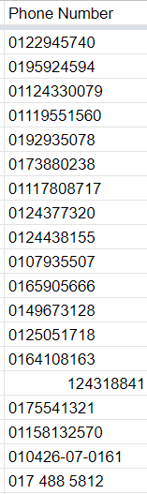

**Q3**

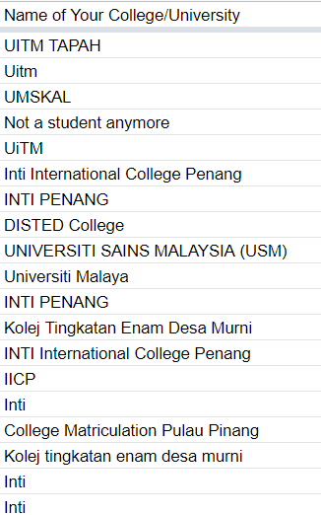

**Q4**

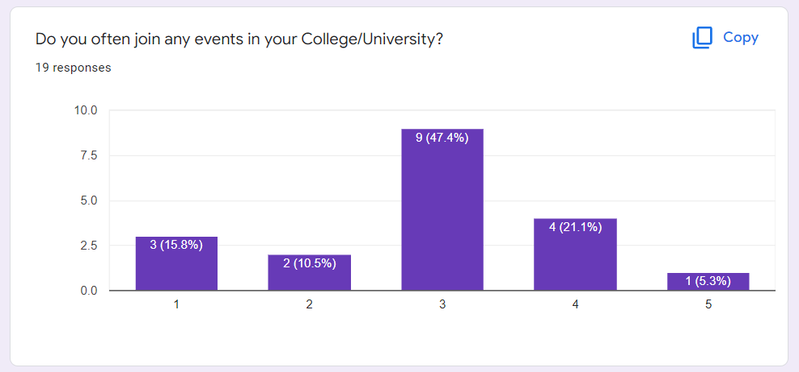

Rating from ‘not really’ to ‘very often’.

**Q5**

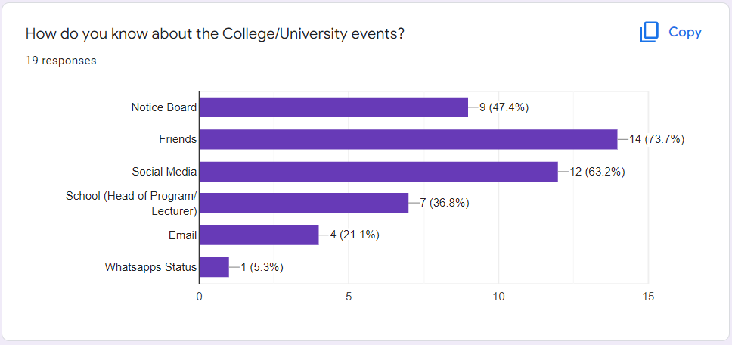

**Q6**

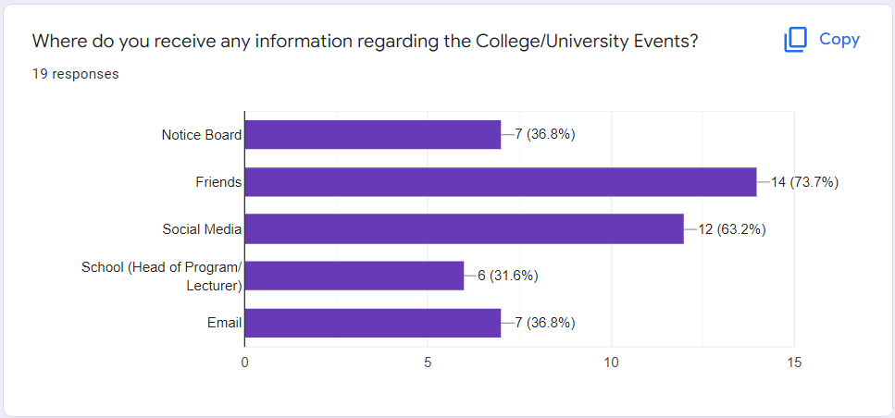

**Q7**

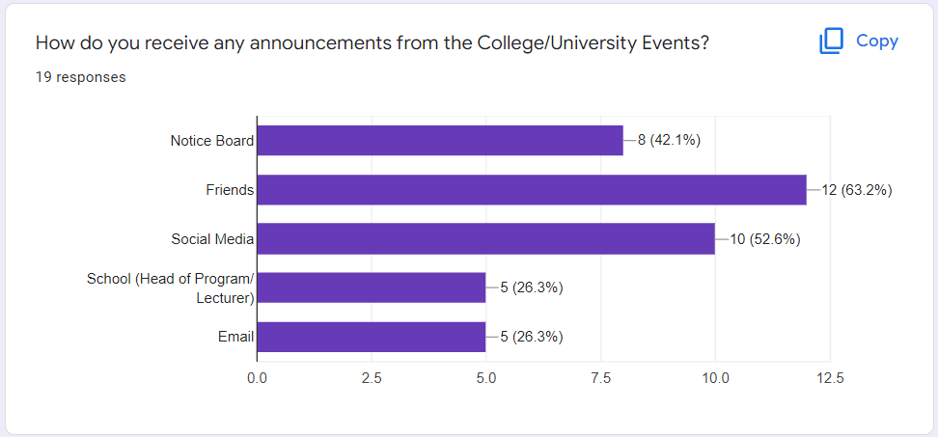

**Q8**

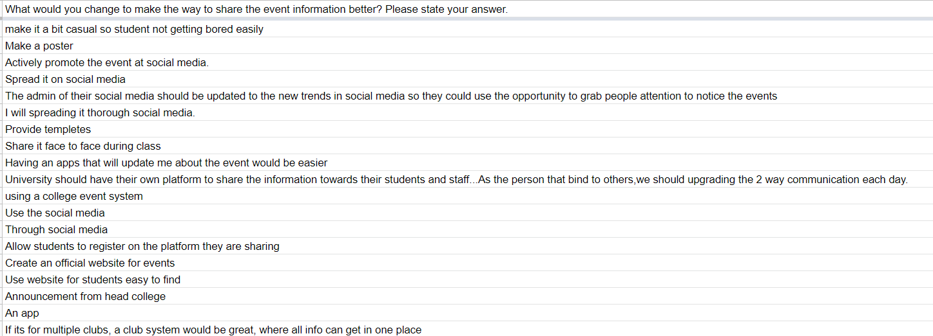

**Q9**

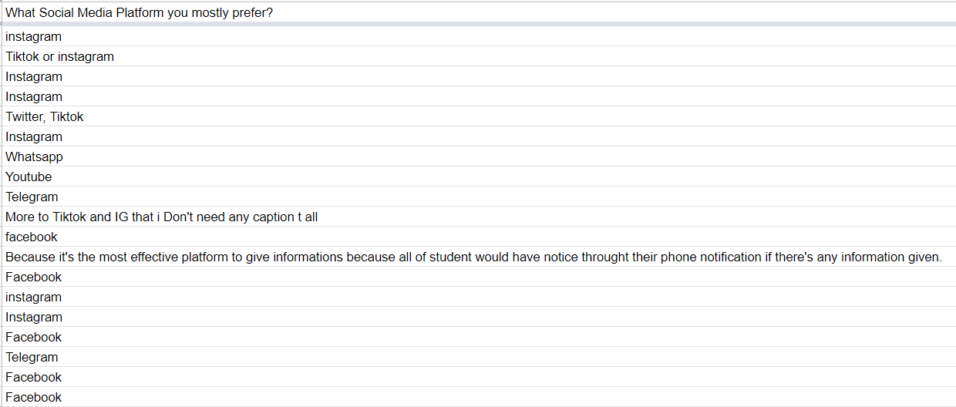

**Q10**

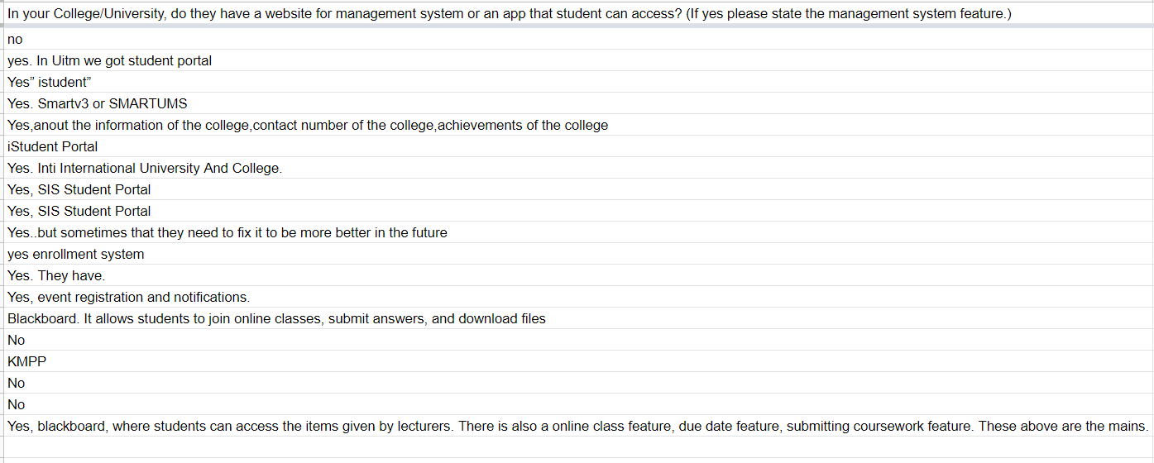

**User Story Mapping Event**

